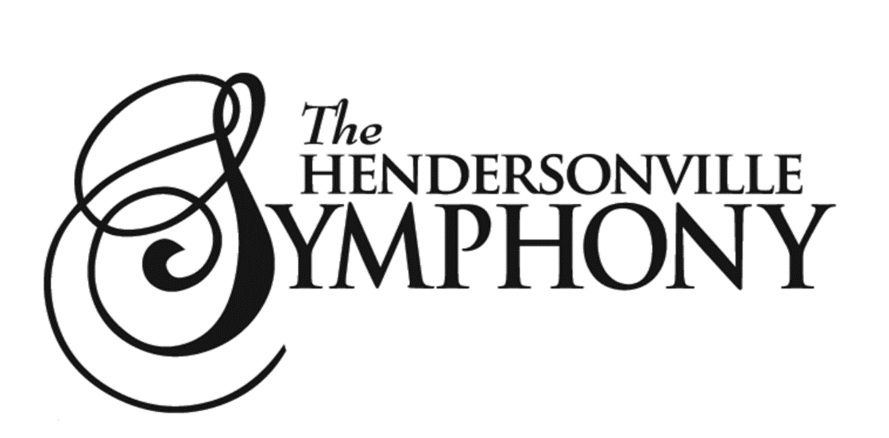

How to Audition:
- Prepare a solo piece of your choice. This can be a regional, all county, or district audition piece, a selection from your school ensemble music, or any other piece that you feel best represents your playing.
- Prepare the excerpt below for your instrument
- Register for auditions and choose an audition time here
- Results will be emailed to you

If you have any questions about joining HSYO, please email elizabeth@hendersonvillesymphony.org.

Excerpt Links: Play the selection marked in red. You do not need to play the repeat. Violins may choose to play the upper or lower line.
Violin
Viola
Cello
Bass
Percussion (choose timpani or bells)
Flute (optional piccolo)
Clarinet
Bassoon
Oboe
Trumpet
Tuba
Trombone
Horn

