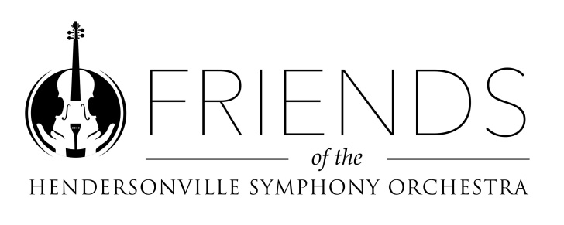

FRIENDS OF THE HENDERSONVILLE SYMPHONY
2022-2023 MEMBERSHIP COMMITMENT

DATE _________________________

NAME _________________________________________________

ADDRESS _______________________________________________

CITY ____________________________ STATE ______ ZIP ________

PHONE _________________________________________________

EMAIL __________________________________________________

We request each member serve on at least one of the Friends’ committees. Please designate your choice below.

I wish to serve on the following committee(s) this year:
□ Concert Hosts committee
□ Special events planning committee
□ Administrative / office committee
□ Membership recruitment / retention committee
□ No preference (will serve where needed most)

Please return this form and dues payment to
HENDERSONVILLE SYMPHONY, PO Box 1811
Hendersonville, NC 28793
Thank you for your continued support of YOUR Symphony!!!

